DYN

1. **Step Response of Overdamped 1st order system**
2. **Step Response of Critically damped 1st order system**
3. **Step Response of Underdamped 1st order system**

Matlab Code:

clc;clear all;

wn=3;

num=9;

den1=[1 7.2 9];

den2=[1 30 9];

den3=[1 0.6 9];

den4=[1 4.2 9];

den5=[1 6 9];

step(num,den1);

hold on

step(num,den2);

step(num,den3);

step(num,den4);

step(num,den5);

grid on

xlabel('t');

ylabel('y(t)');

title("1ST ORDER UNIT STEP RESPONSE");

legend('\xi=1.2','\xi=5','\xi=0.1','\xi=0.7','\xi=1',Location='BEST');



1. **%OS vs damping ratio**

Matlab Code:

clear all;clc;

grid on

fplot(@(si) exp((-1*si*pi)/sqrt(1-(si^2))),[0 0.999]);

ylabel('% MP');

xlabel('\xi');

hold on

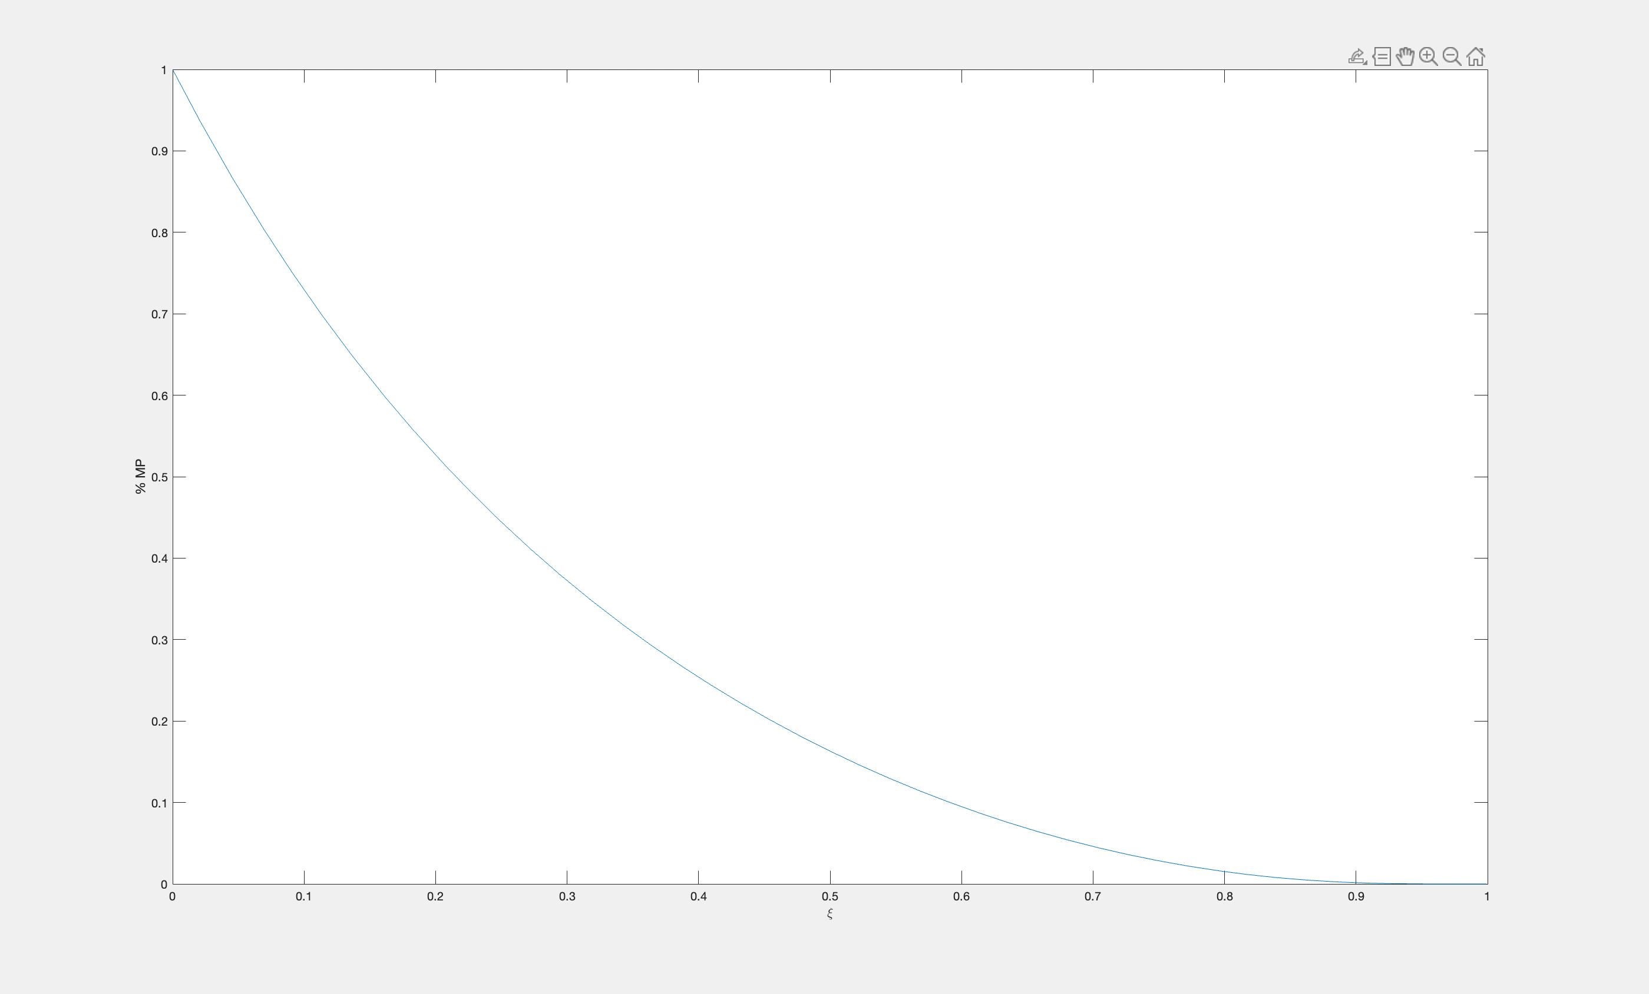

1. **a) Ramp response of 2nd order instruments**

Derivation:



Matlab Code:

clear all;

clc;

t=[0:0.05:10];

ramp= 1*t;

x=tf(25,[1 1.8 81]);

y=tf(25,[1 18 81]);

z=tf(25,[1 90 81]);

[q,t]=lsim(x,ramp,t);

hold on

[r,t]=lsim(y,ramp,t);

[s,t]=lsim(z,ramp,t);

plot(t,q);

plot(t,r);

plot(t,s);

plot(ramp,t);

legend({'\xi<1','\xi=1','\xi>1','t'},Location='best');

xlabel('t');

ylabel('y(t)');

grid on

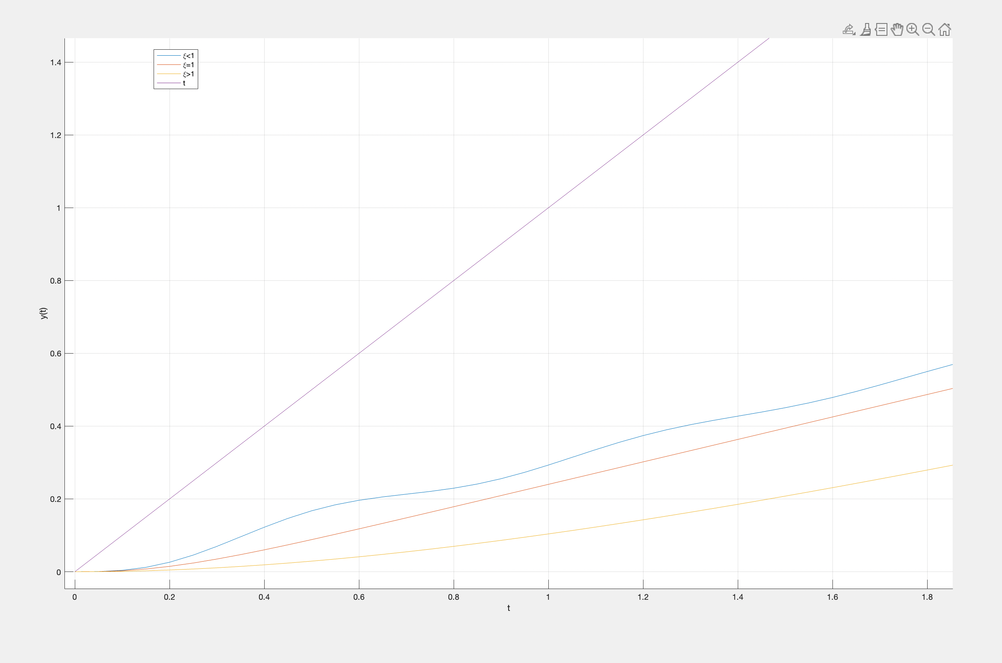

**b) Sallen Key LPF simulation**

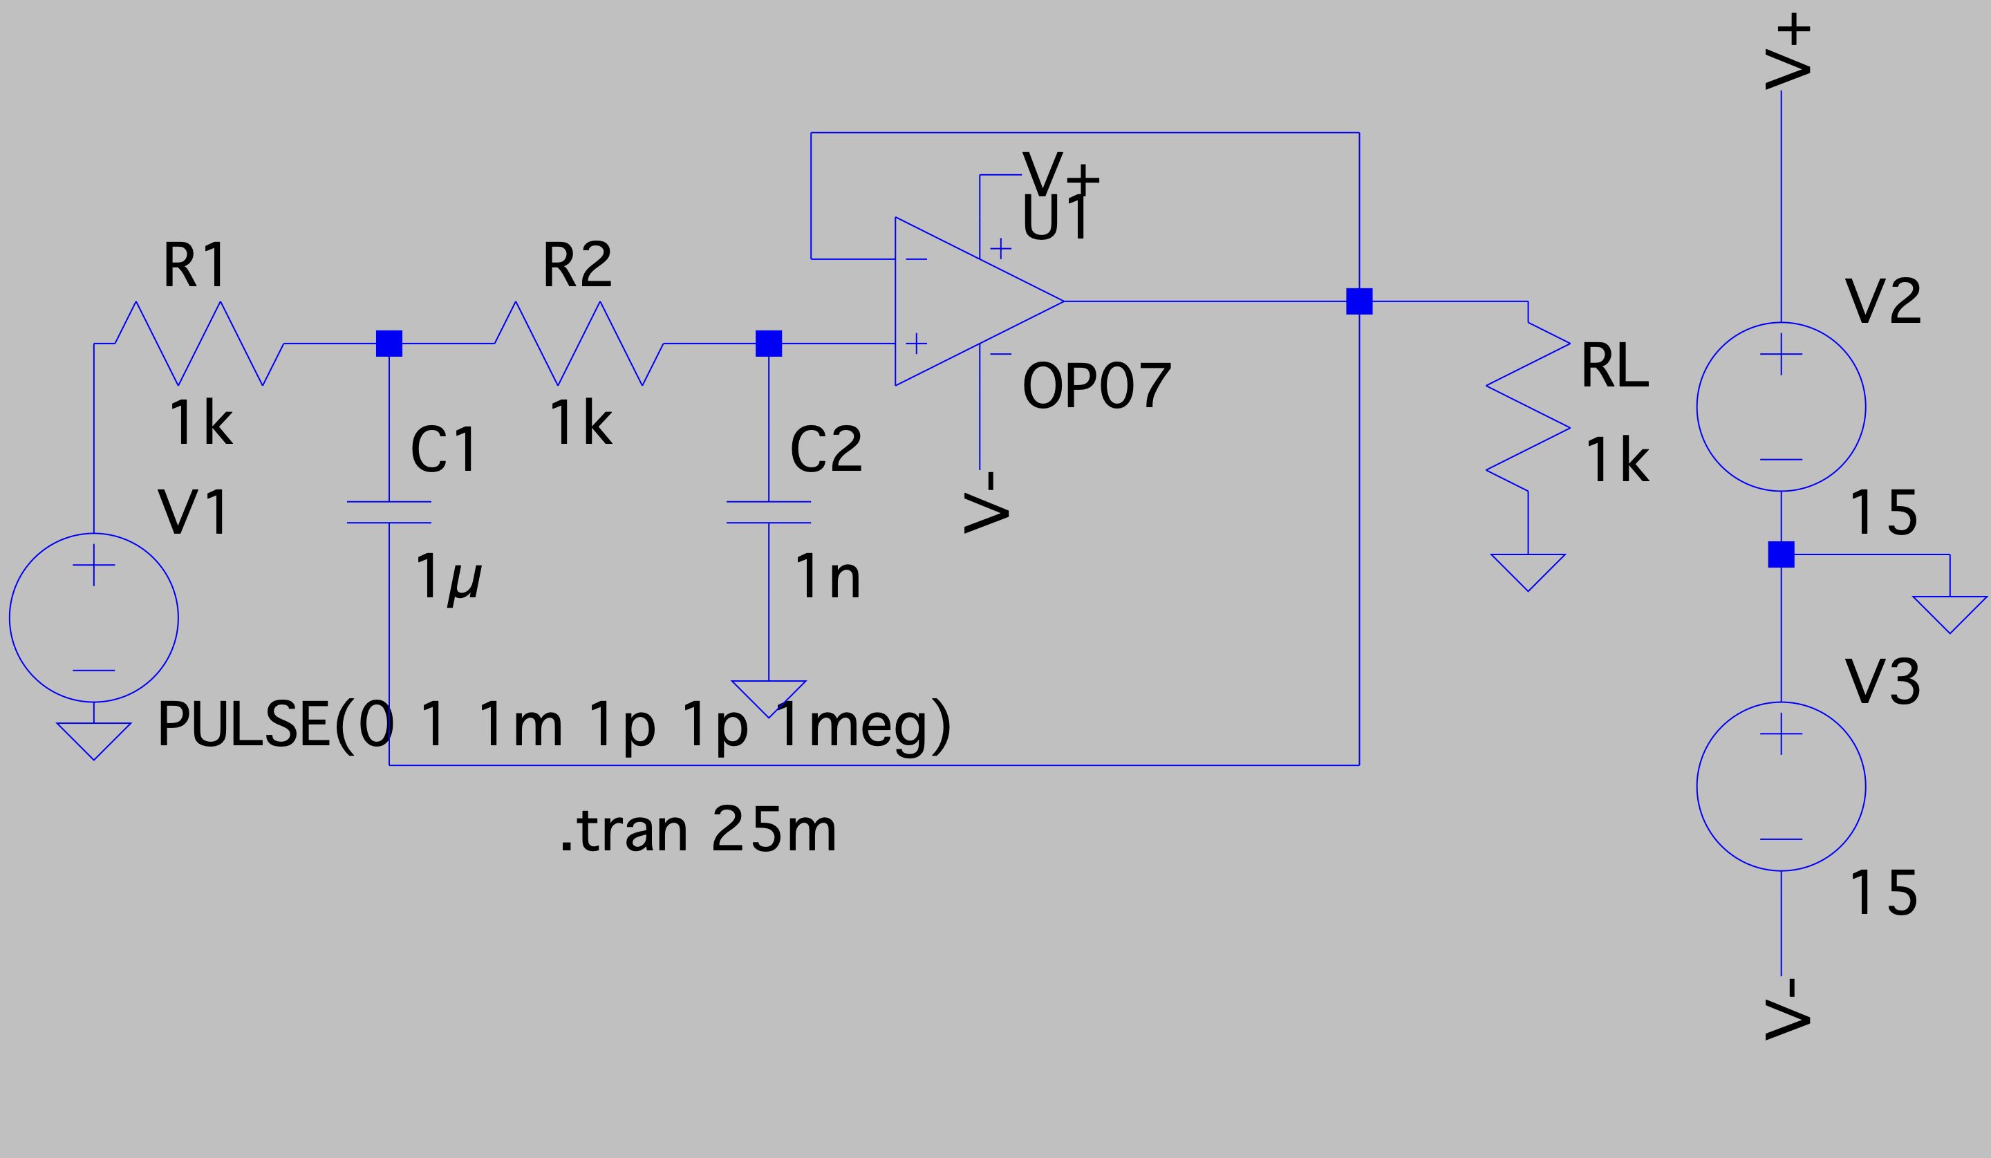

The plots are the corresponding frequency response and unit step response:

Underdamped with $ξ=0.032$.

R1=1k $Ω$, R2=1k $Ω$, C1=1 $μF$, C2=1nF.

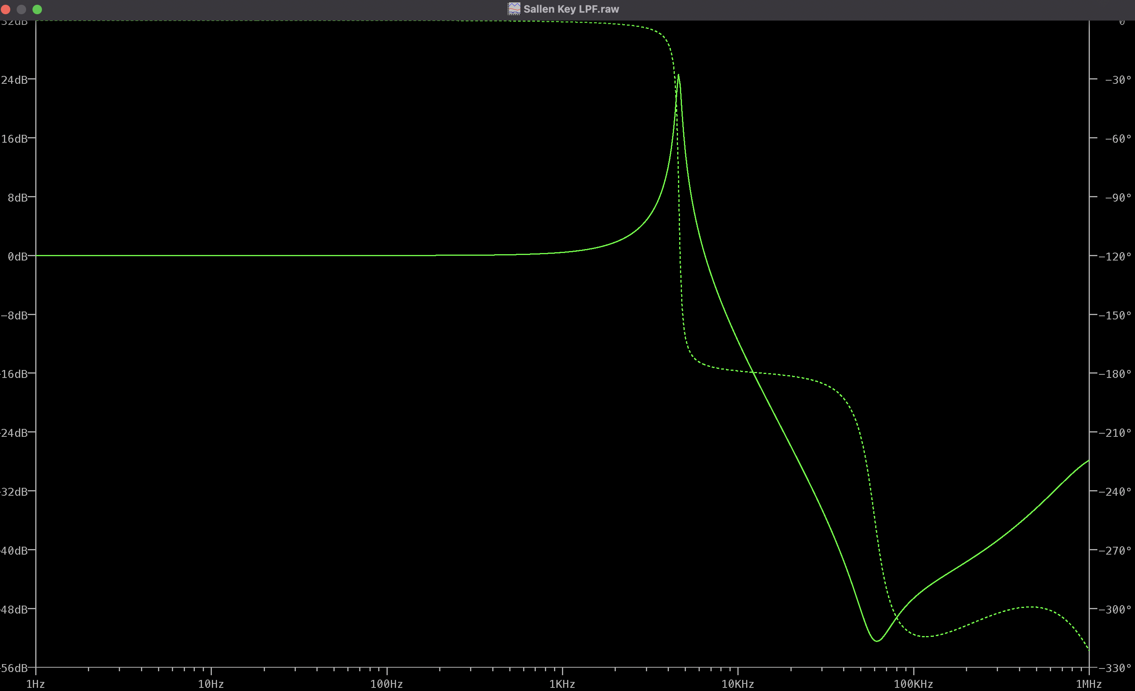

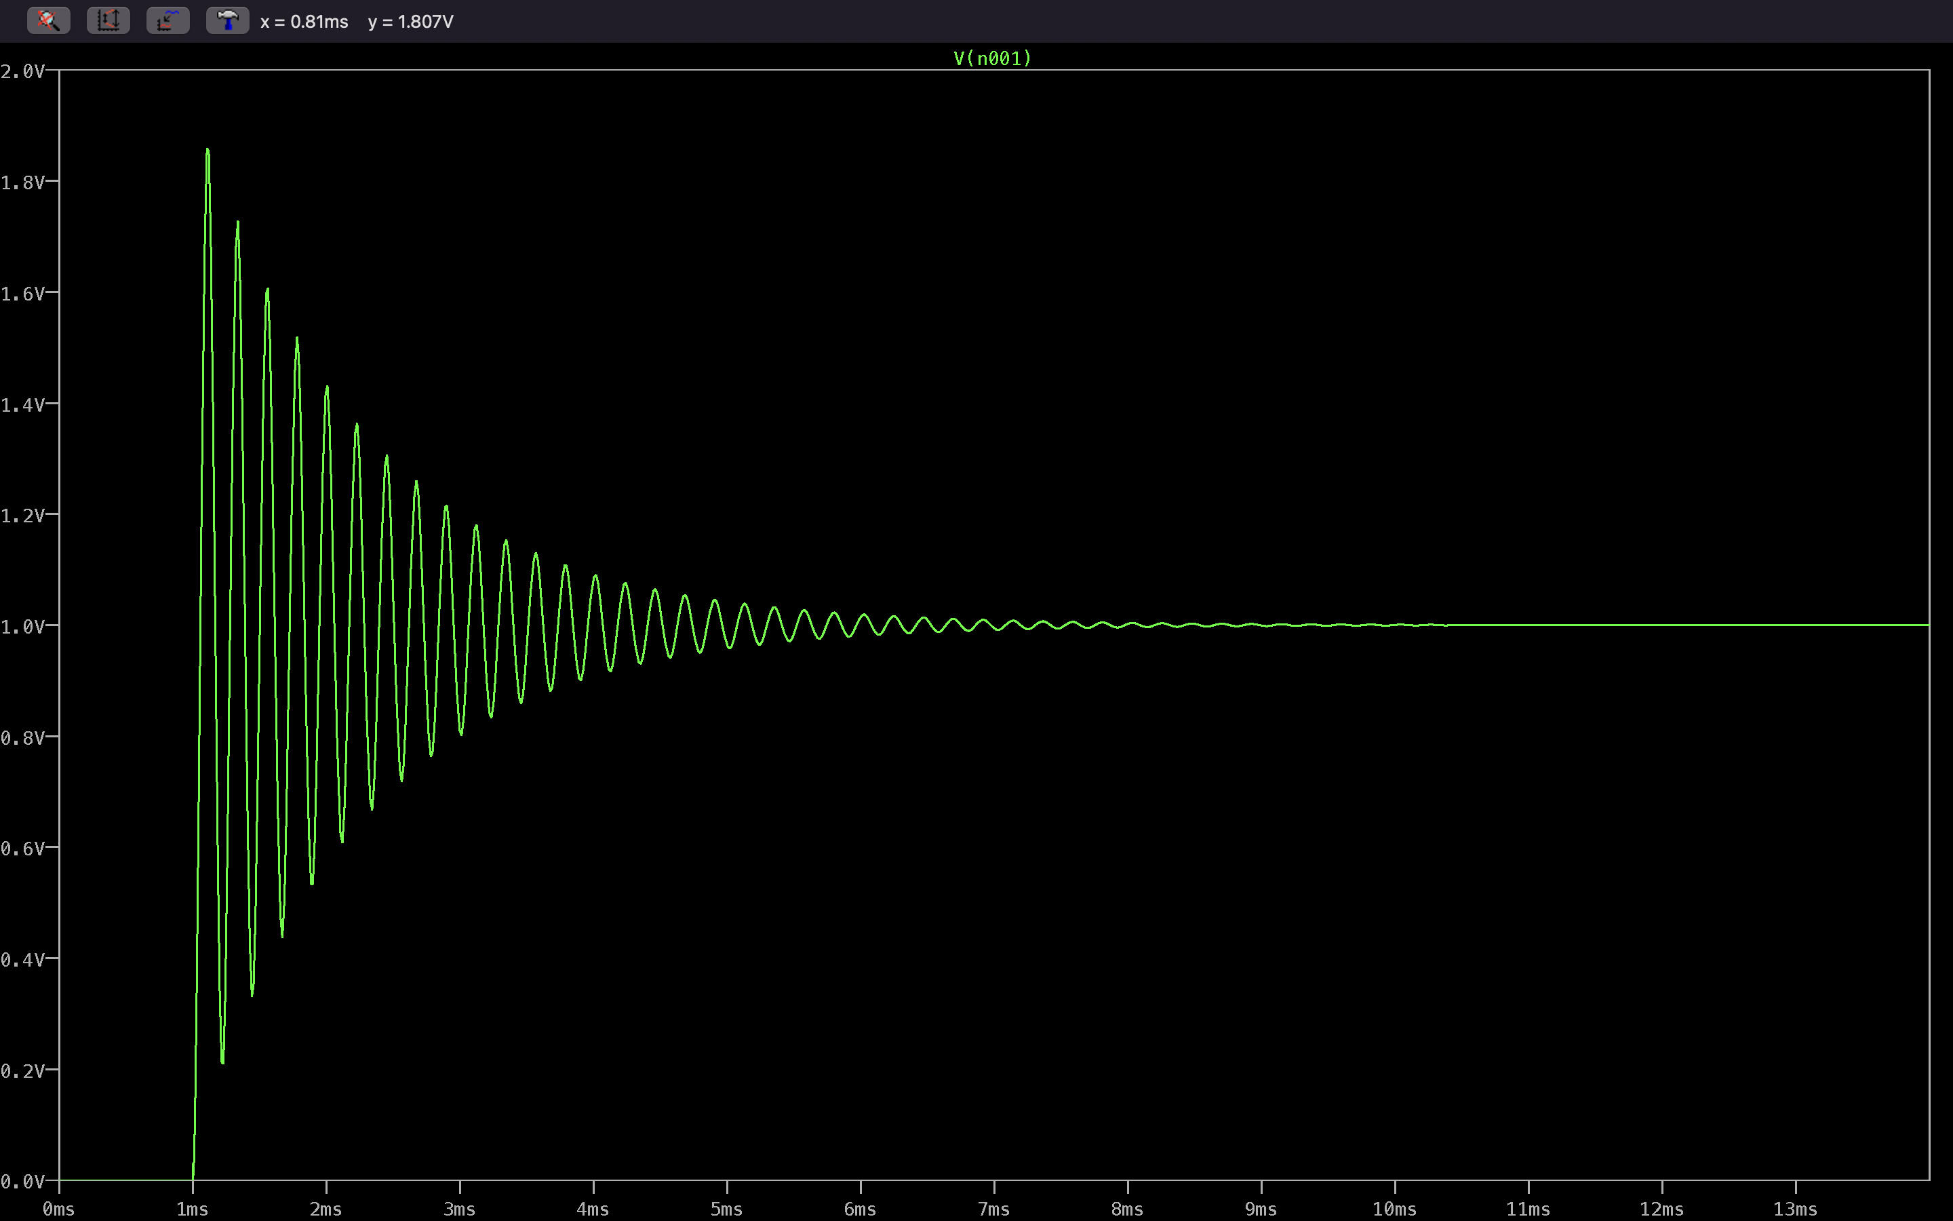

R1=1k $Ω$, R2=1k $Ω$, C1=2200p $F$, C2=1nF.

Underdamped with $ξ=0.674.$

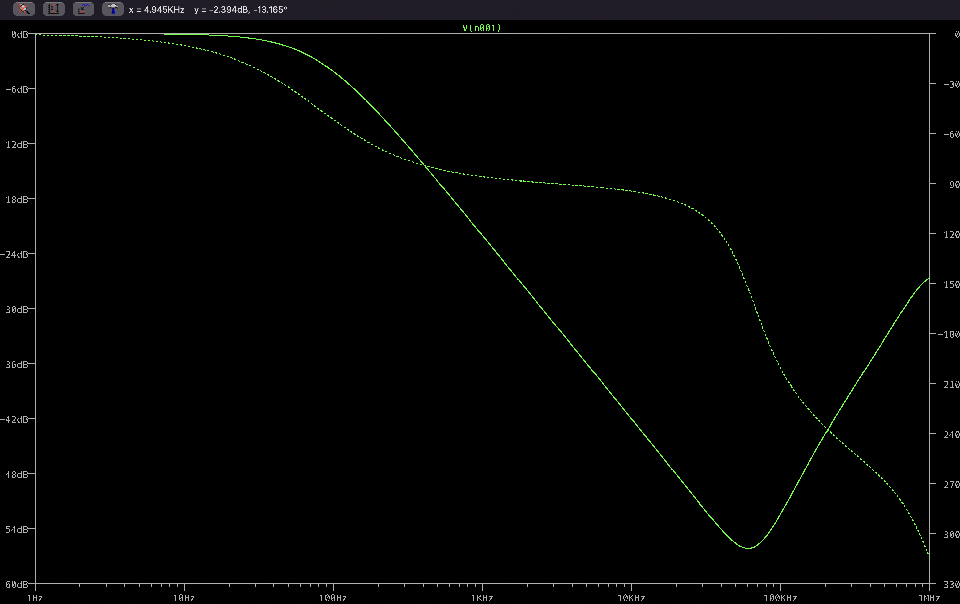

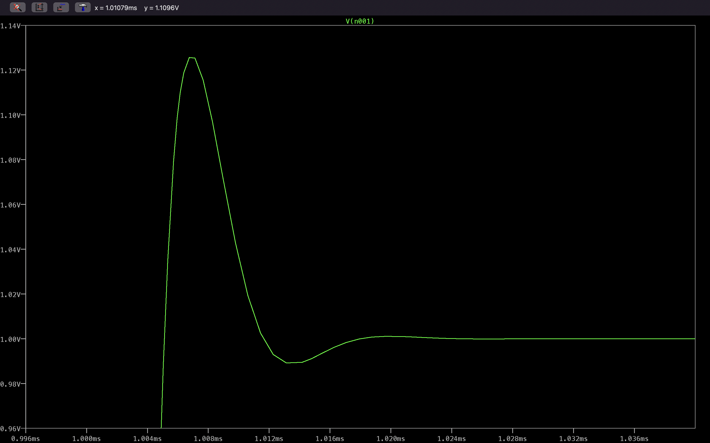

R1=1k $Ω$, R2=1k $Ω$, C1=1 $600pF$, C2=1nF.

Underdamped with $ξ=0.79$

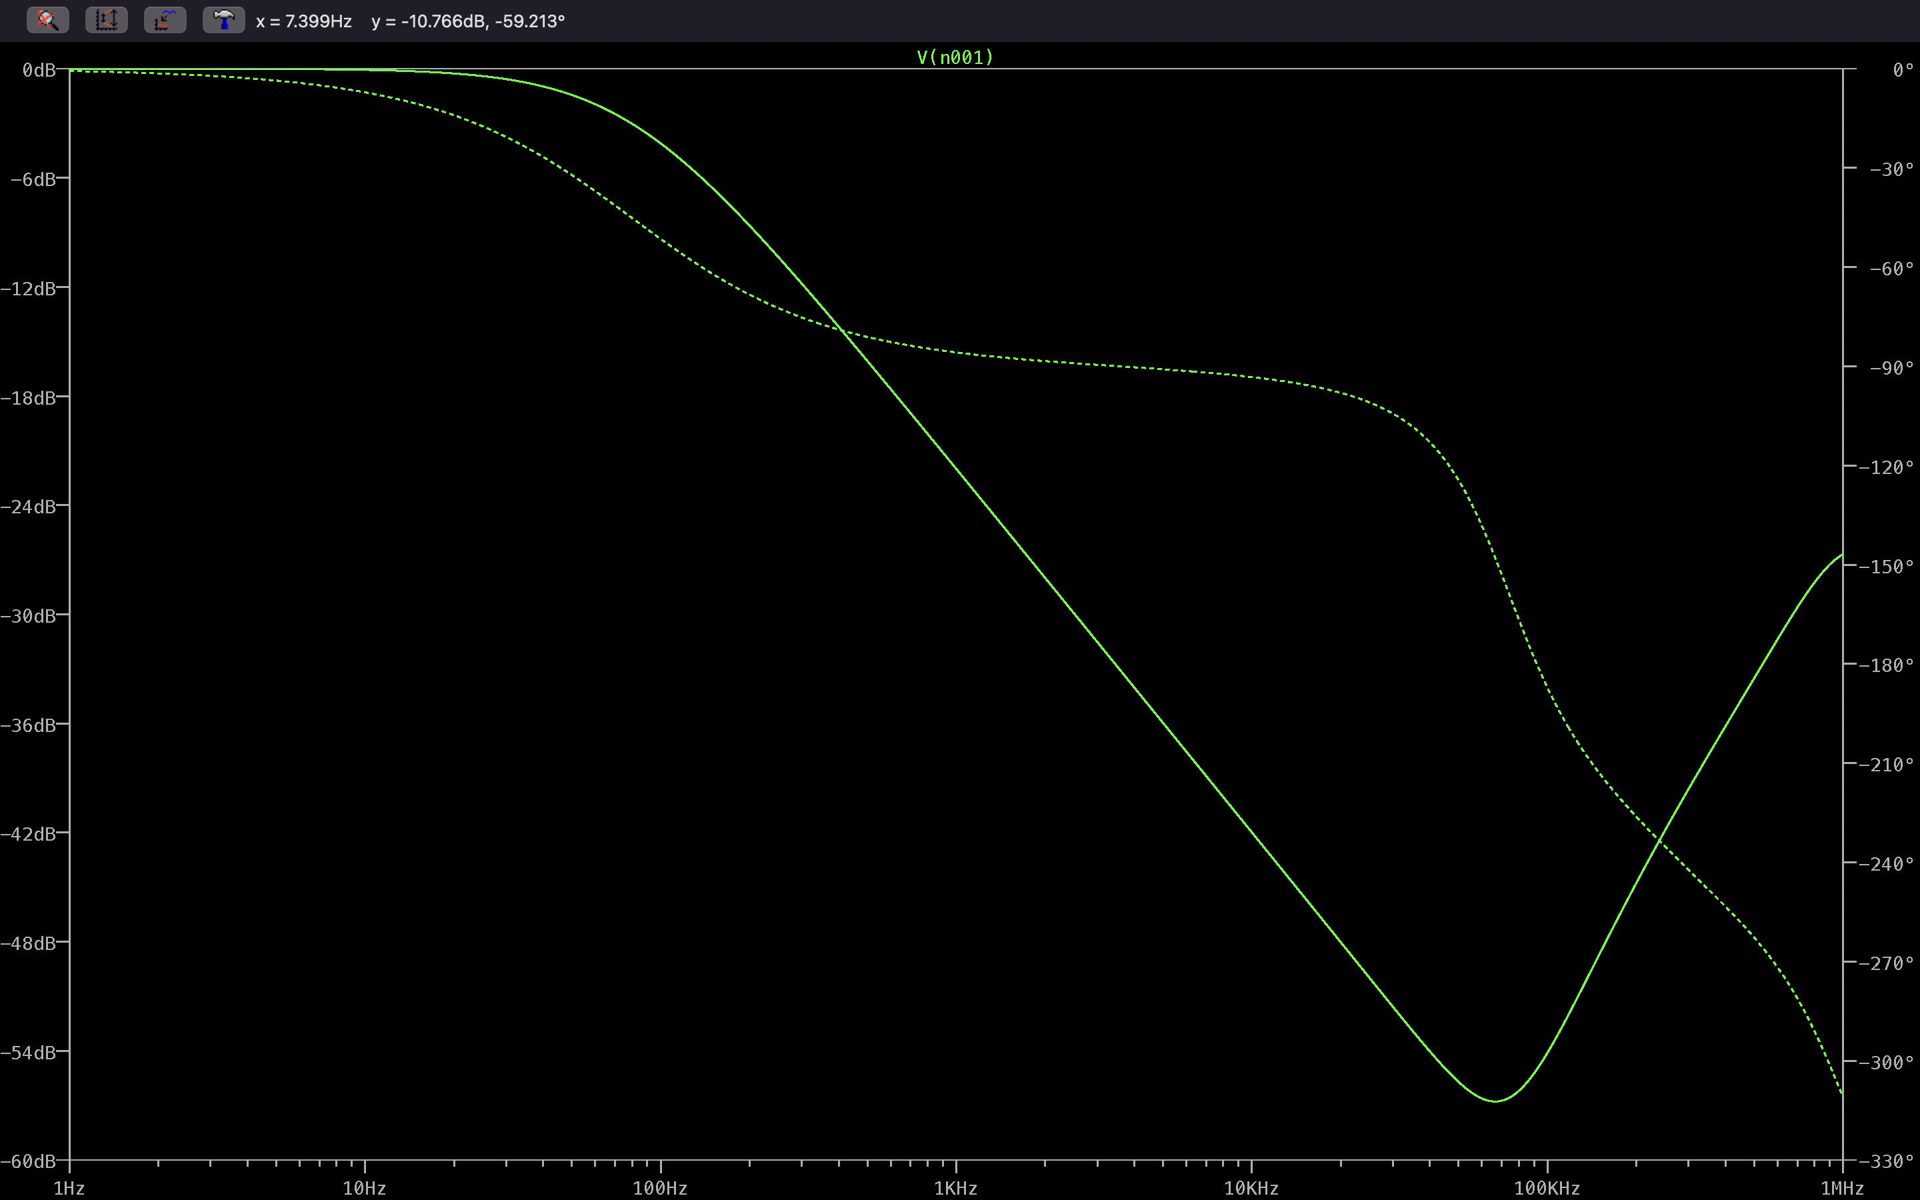

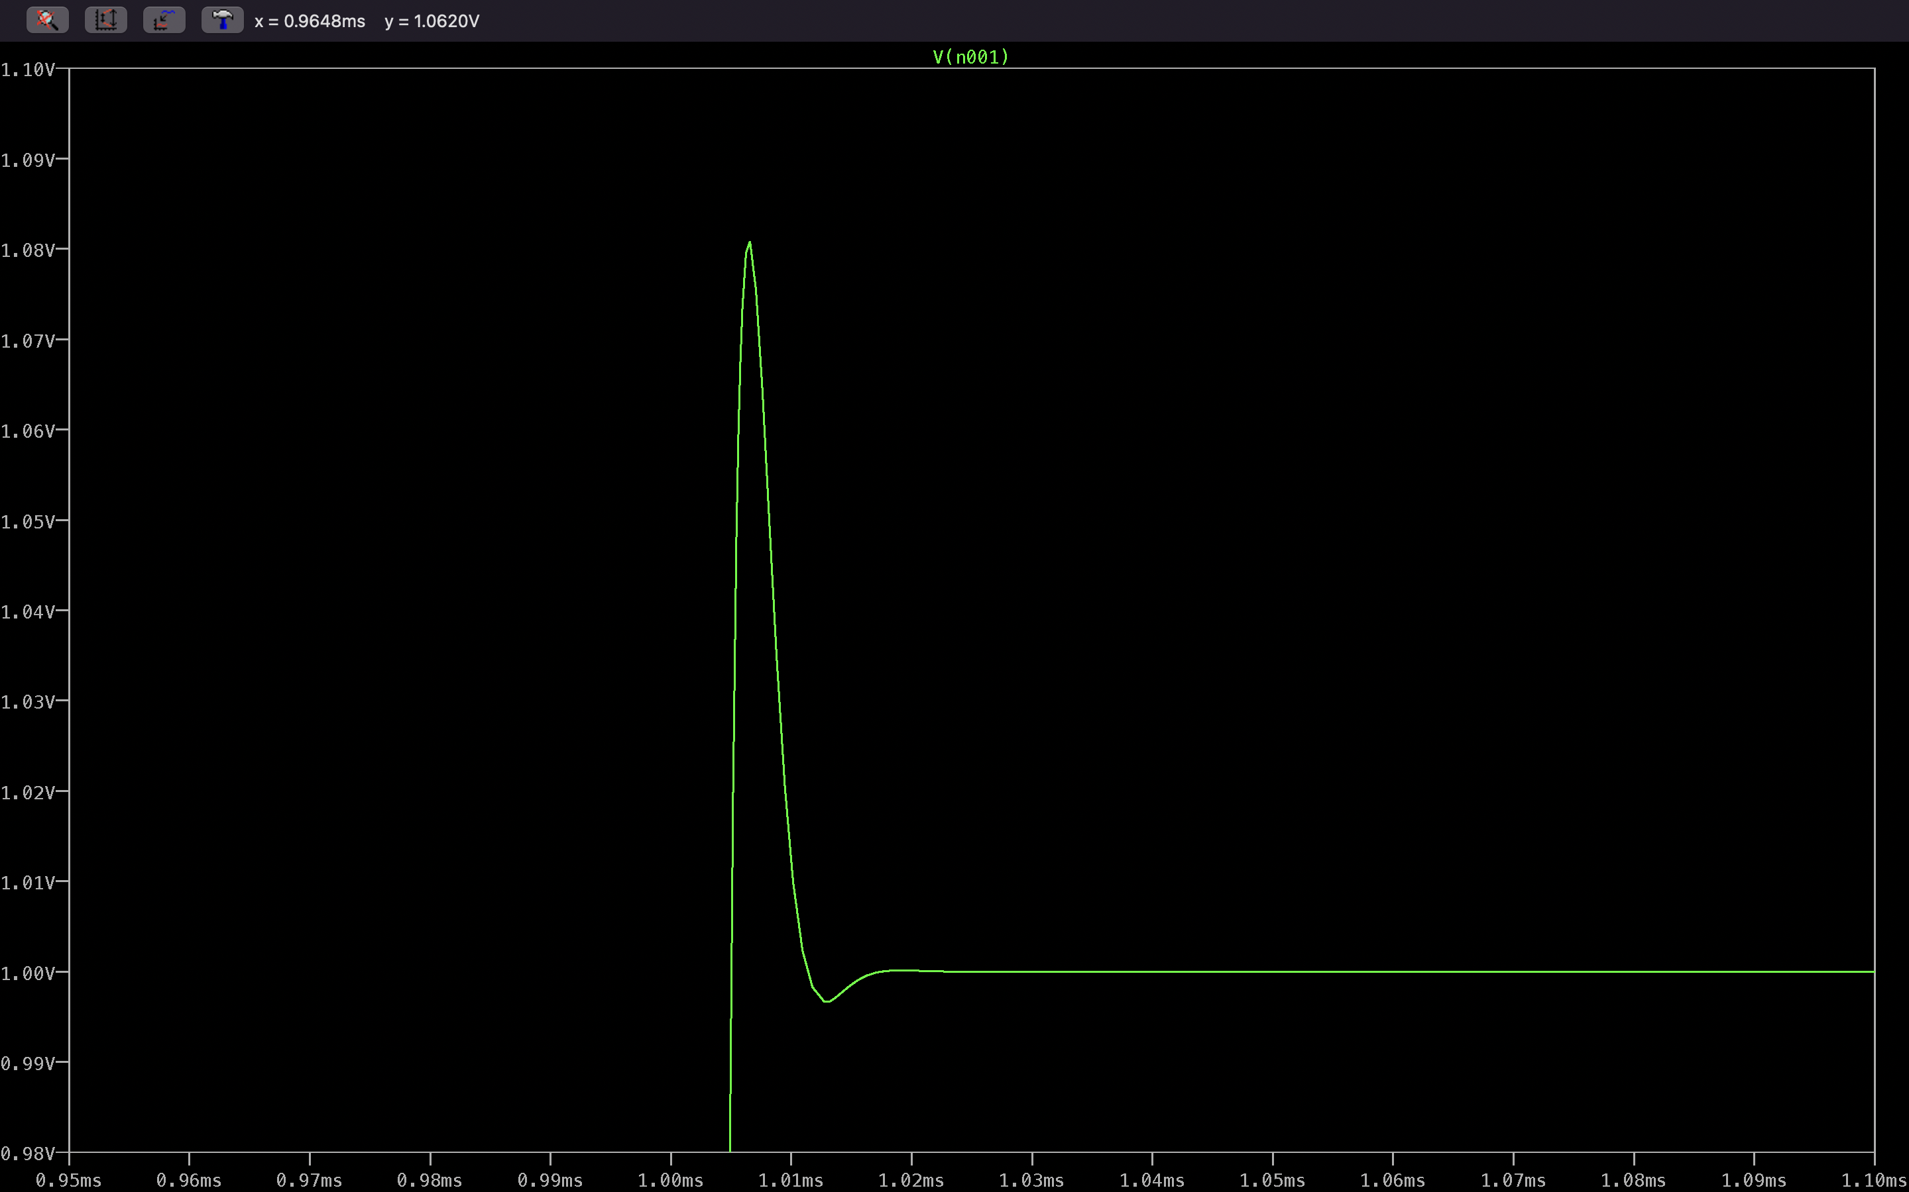

R1=1k $Ω$, R2=1k $Ω$, C1=1 $00nF$, C2=100nF.

Critically Damped

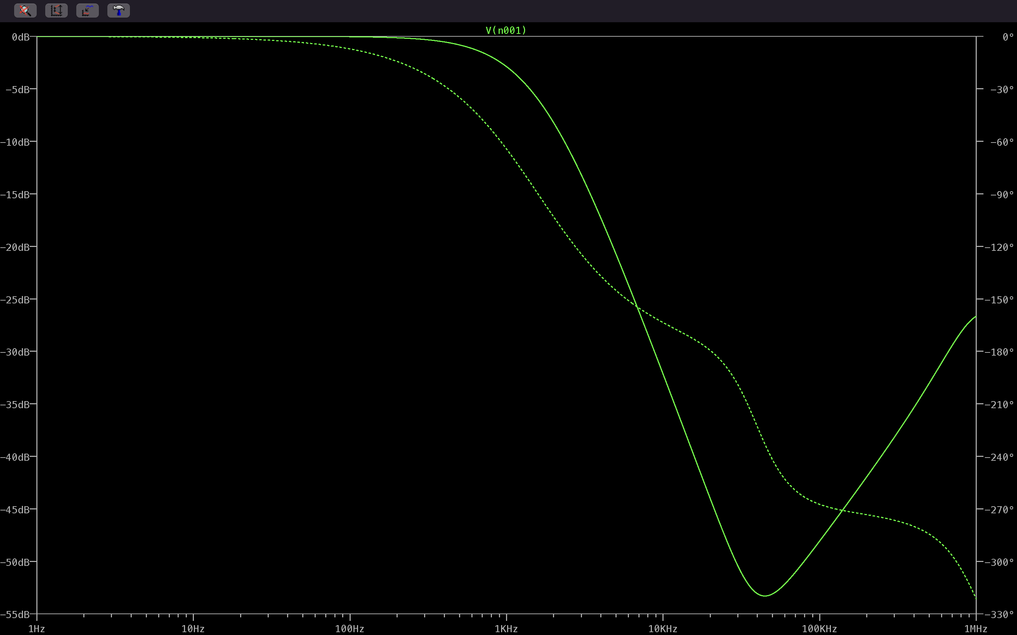

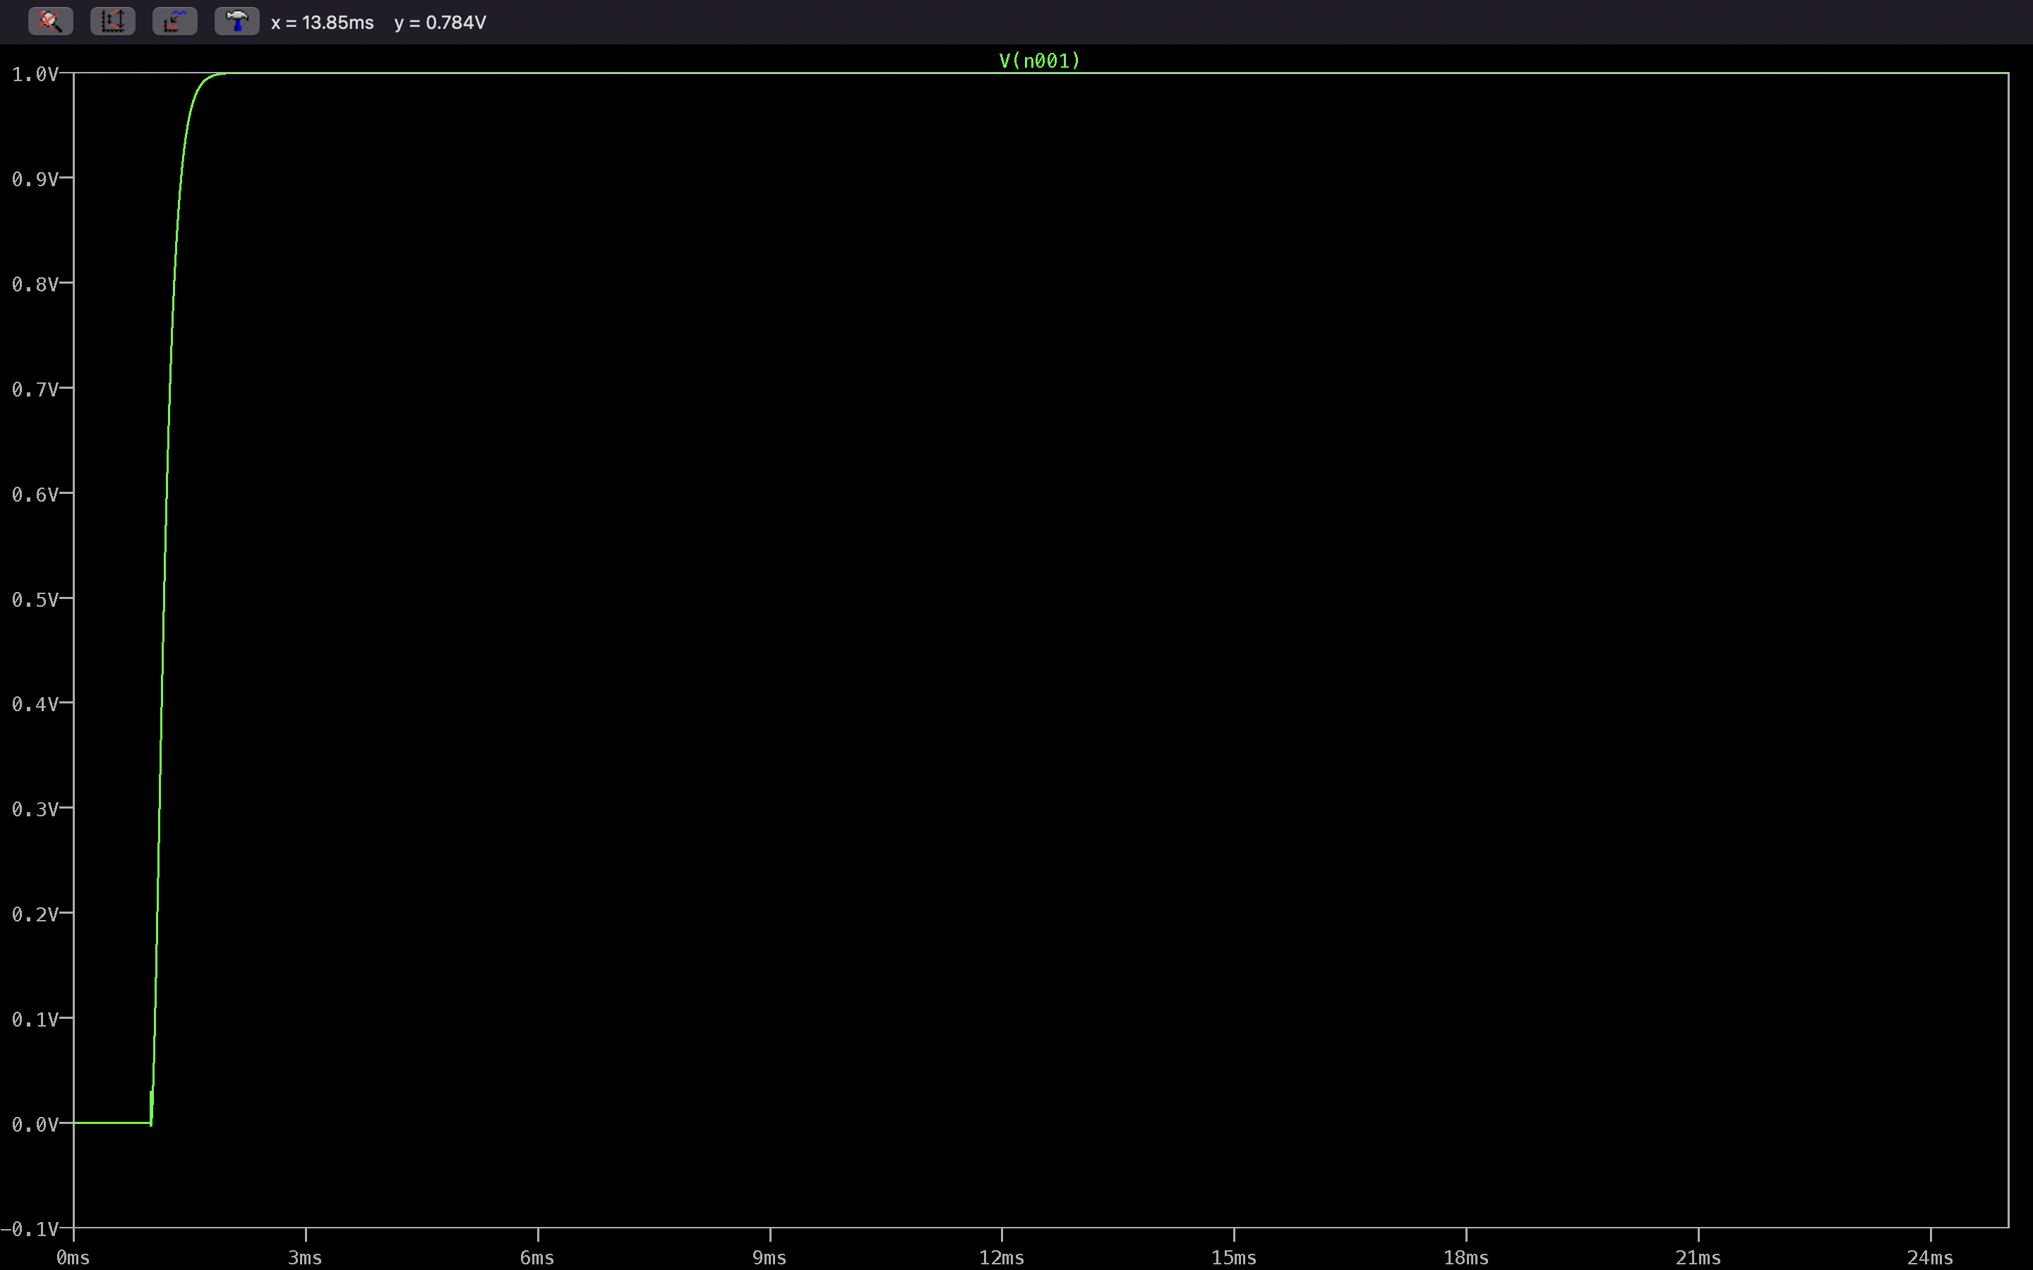

R1=1k $Ω$, R2=1k $Ω$, C1=1 $00nF$, C2=1 $μ$ F.

Overdamped with $ξ=3.1622$

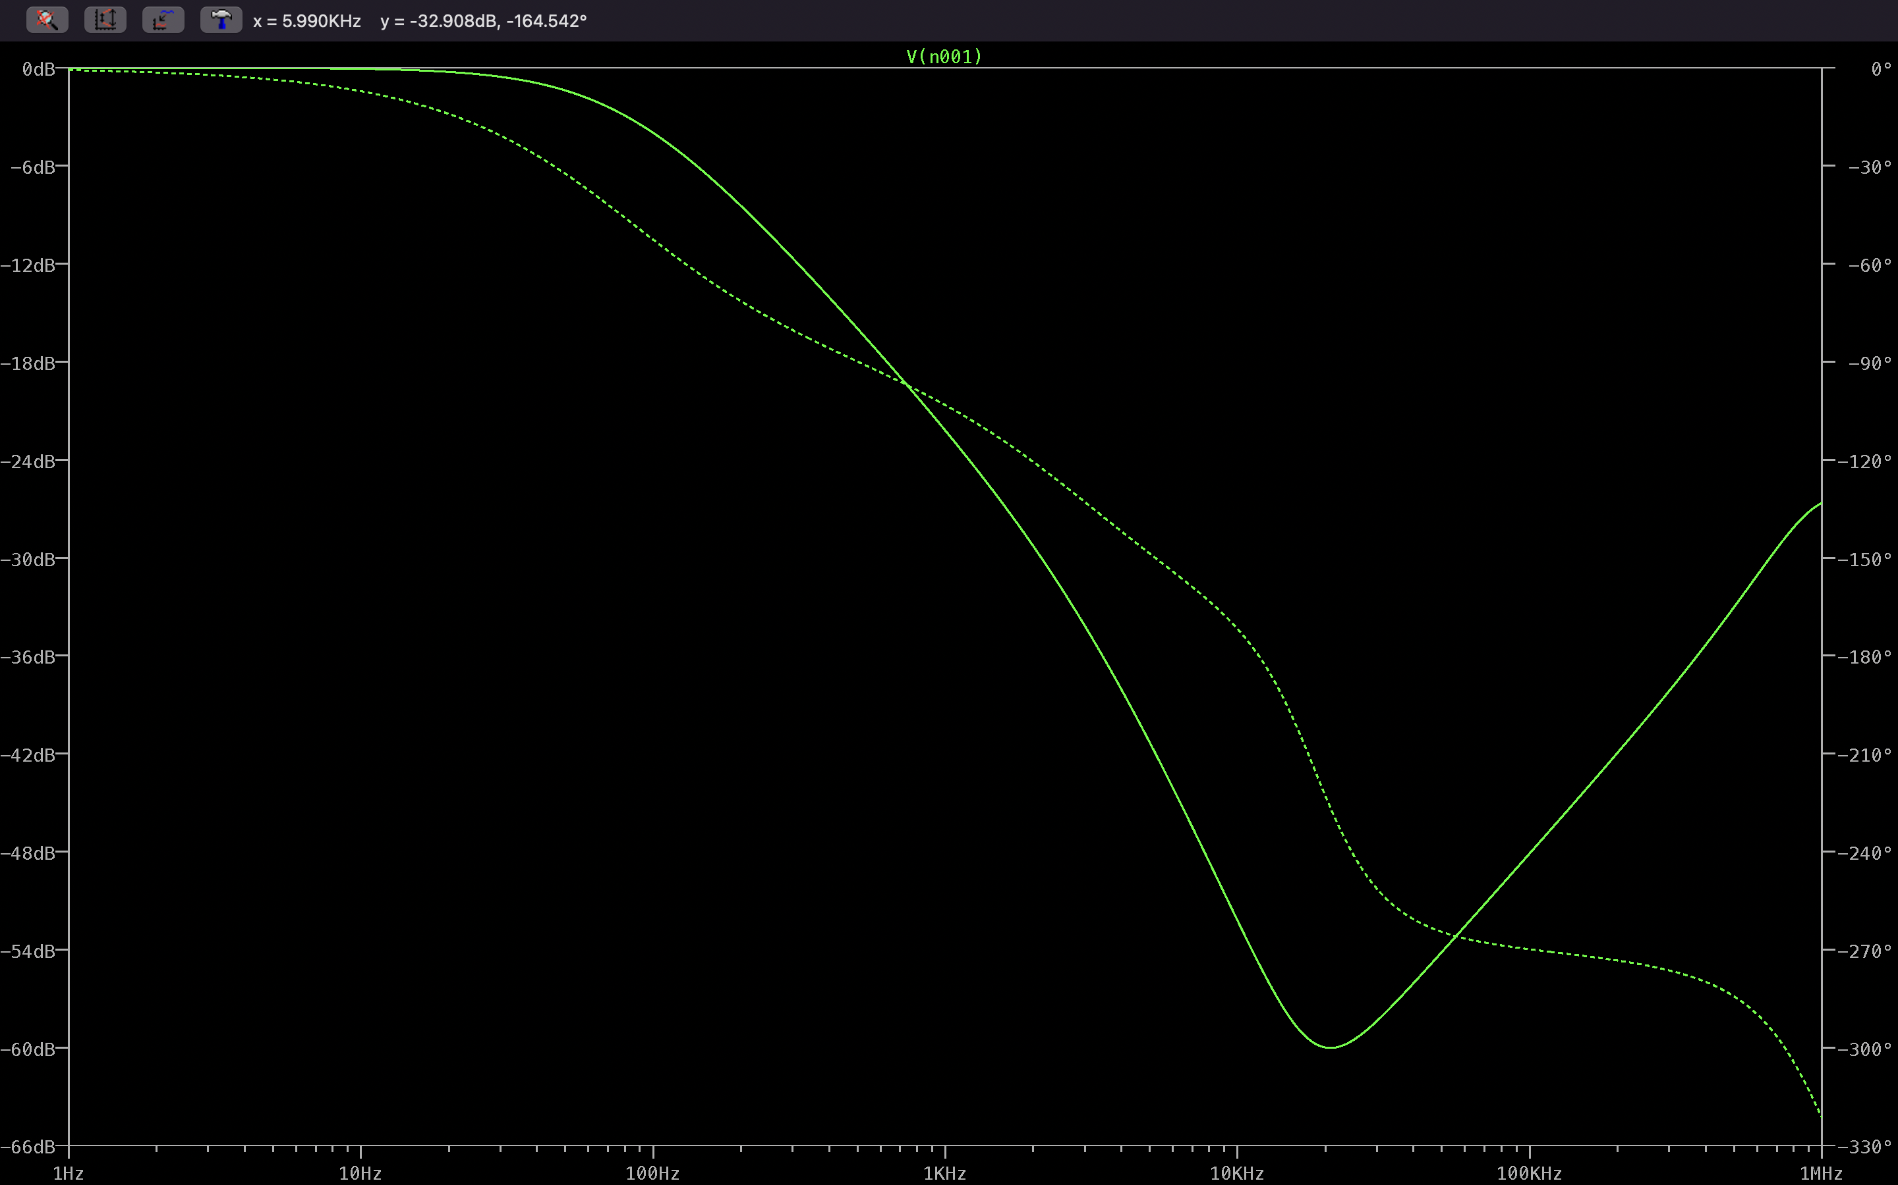

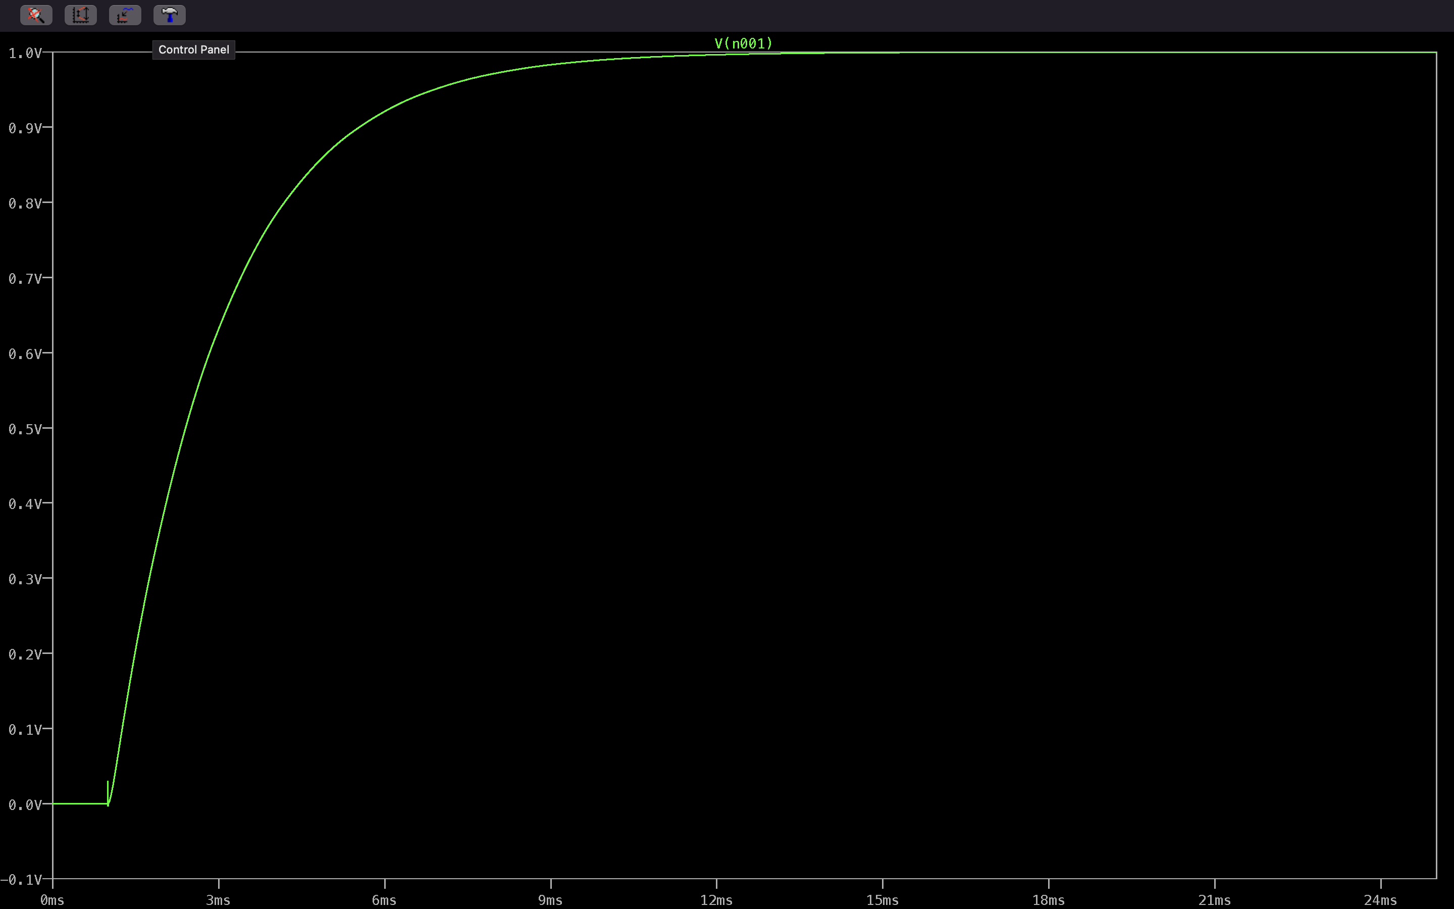

1. Frequency response of 2nd order instruments

Code:

clear all;

clc;

wn=3;

w=logspace(-1,2,100);

num=9;

den1=81./sqrt(((9-w.^2).^2)+0.64*9*w.*w);

den2=81./sqrt(((9-w.^2).^2)+1.44*9*w.*w);

den3=81./sqrt(((9-w.^2).^2)+2.56*9*w.*w);

den4=81./sqrt(((9-w.^2).^2)+4*9*w.*w);

den5=81./sqrt(((9-w.^2).^2)+16*9*w.*w);

grid on

semilogx(w,20*log10(den1));

hold on

semilogx(w,20*log10(den2));

semilogx(w,20*log10(den3));

semilogx(w,20*log10(den4));

semilogx(w,20*log10(den5));

legend({'\xi=0.4','\xi=0.6','\xi=0.8','\xi=1','\xi=2'},Location='best');

xlabel('f');

ylabel('Gain(dB)');

title('FREQUENCY RESPONSE OF 2ND ORDER INSTRUMENTS');

grid on

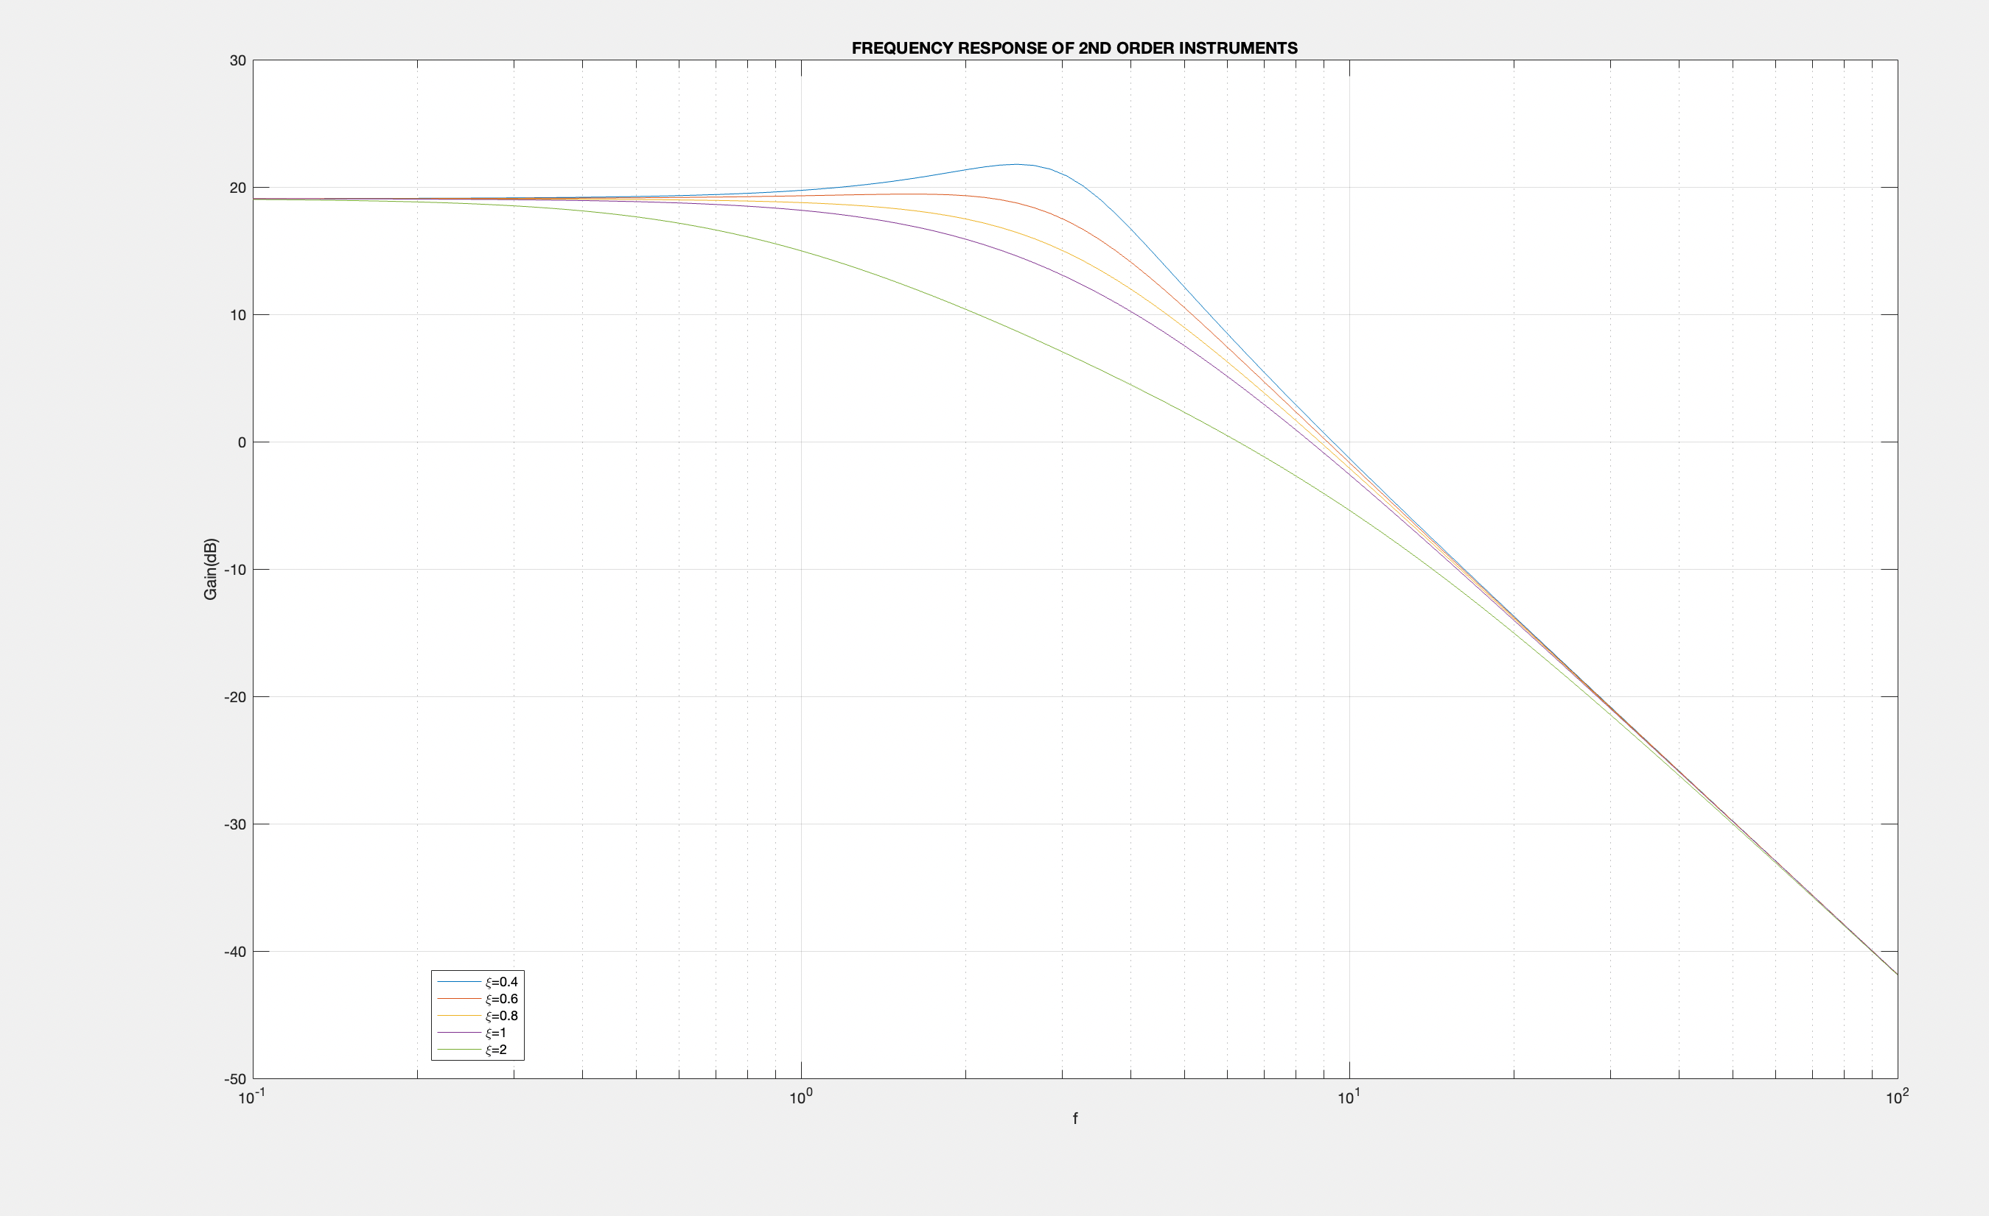

By Nithin M

SC20B101